**GUIDELINES**

|  |  |  |  |
| --- | --- | --- | --- |
| **Solution** | Big, Project – Application of Knowledge | | |
| **Description** | HBaseTable project for Apache HBase | | |
| **Author** | Viet-Hung Duong | **Drafted Date** | 10/22/2016 |
| **Reviewed** |  | **Reviewed Date** |  |
| **Version** | 0.1 | **Last Modified Date** |  |

Table of Contents

Purpose 3

Apache HBaseTable setup 3

Configuration Prequiste and cloudera setup 3

HBaseTable project 3

Create Apache Hbase project with Maven 3

Context project 4

Run batch file 5

References 5

# Purpose

This document describes how to set up and configure Apache Hbase installation and instruct how to create a NoSQL database based on Apache Hbase.

# Apache HBaseTable setup

## Configuration Prequiste and cloudera setup

Please refer to document in Hadoop project.

## HBaseTable project

### Create Apache Hbase project with Maven

1. Create new Maven project

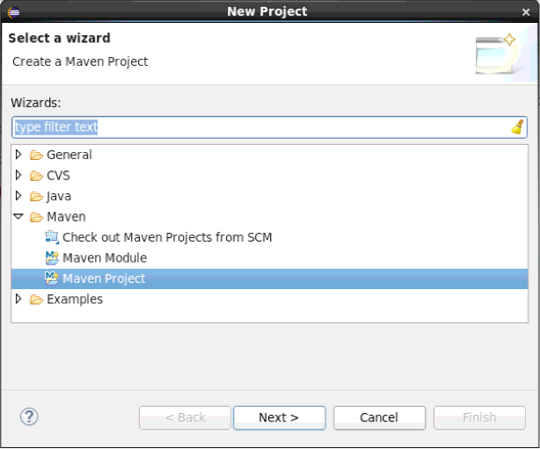

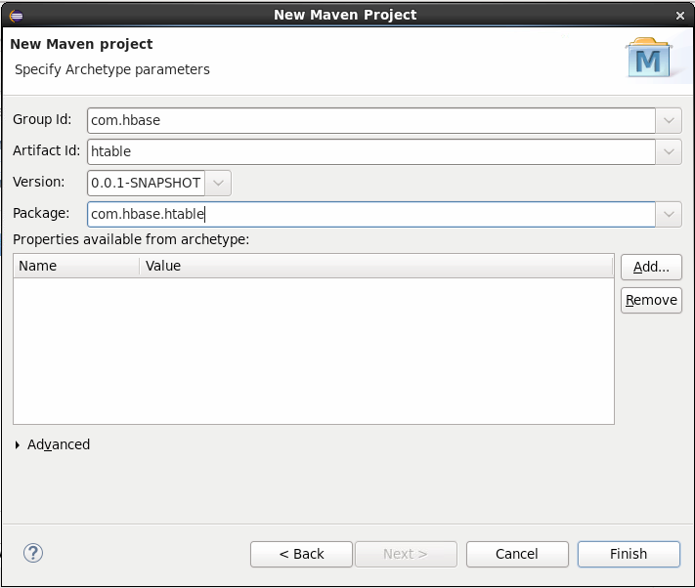

1. Add hbase-client dependency

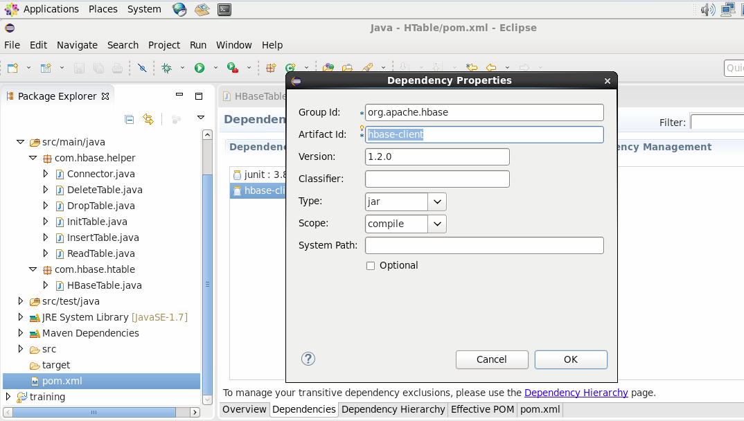

### Context project

We would like create a NoSQL database based Apache Hbase as below. We will use the operations that Hbase support to operate this table such as:

* Put: add and update row.
* Scan: retrieve a ranges of cells
* Get: return cells for a specific row
* Delete: remove rows, cloumn from the table

|  |  |  |  |  |  |  |
| --- | --- | --- | --- | --- | --- | --- |
| **RowID** | **PersonalData** | | | | **ProfessionalData** | |
| **FirstName** | **LastName** | **Address** | **City** | **Designation** | **Salary** |
| row_01 | Mickey | Mouse | 123 Fantascy way | Anaheim | Manager | 50.000 |
| Row_02 | Bat | Man | 321 Carven Ave | Paradise | Sr. Engineer | 30.000 |

Based on the idea about, we have designed the program as image below. There are two packages helper and htable.

* **Helper**: include all the operations that operate on the table like InitTable, DropTable, DeleteTable, InsertTable, ReadTable. All the class are defined as singleton in order to make sure that only one instance is created when operating on the table.
* **Htable**: include the driver using the operations in helper to init the table, add row, delete row, delete cell in table and scan table.

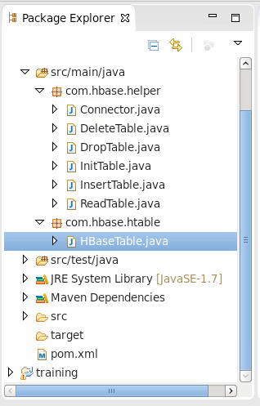

### Run batch file

1. Copy the HBase project folder to local
2. Open the terminal
3. Cd to Hbase project
4. Complile the batch file by command: **chmod +x run_hbase _job.sh**
5. Execcute command: **sh ./run_hbase _job.sh type**

# References

<http://www.tutorialspoint.com/hbase/>